Preliminary overview
SSL uses two cryptographic system: symmetric encryption system and asymmetric encryption system,so let’s take a look at them.
Symmetric system:
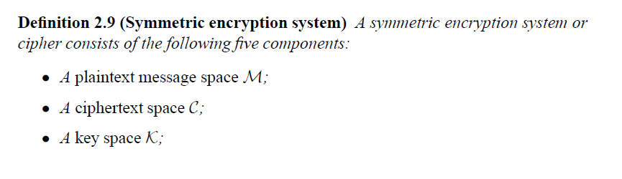
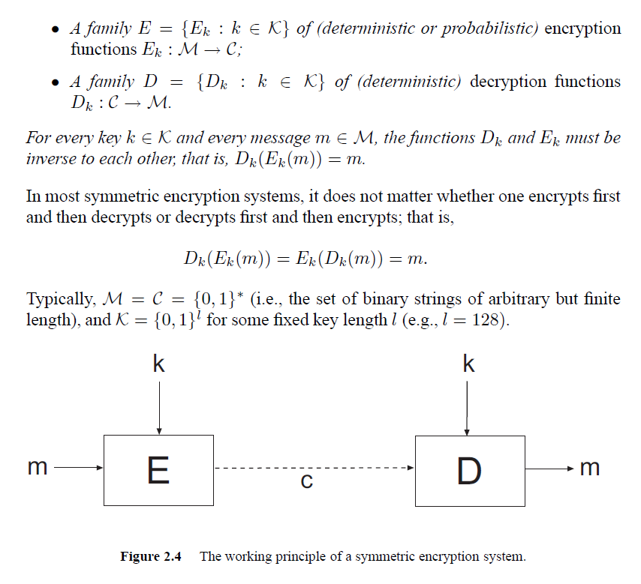
Asymmetric system;
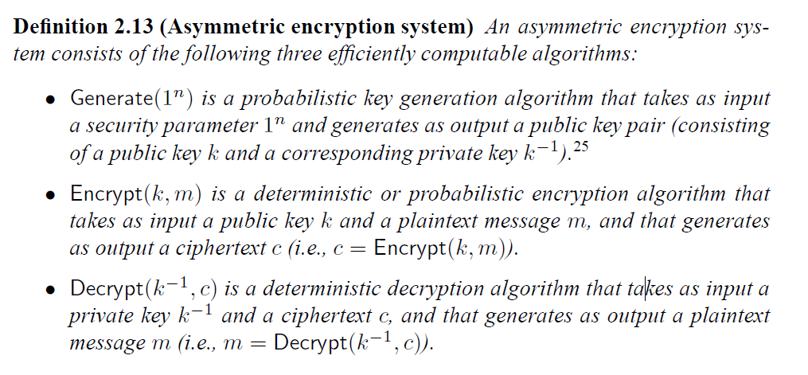
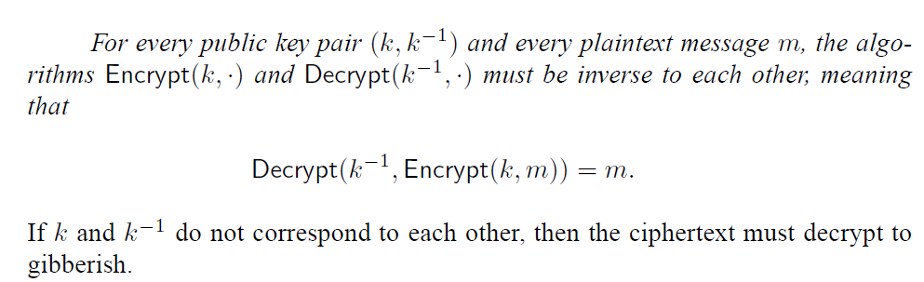
An implementation of asymmetric encryption system is RSA:
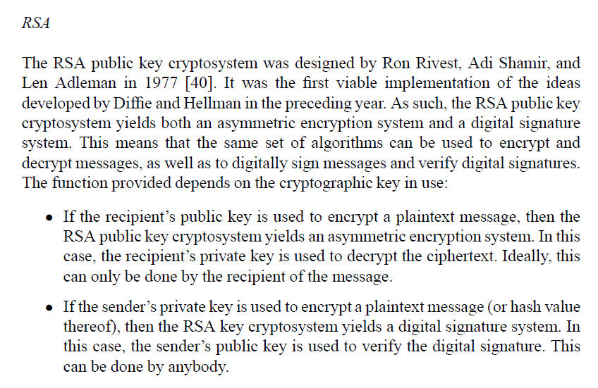
RSA is two algorithms, one for asymmetric encryption, and one for digital signatures. with asymmetric encryption, you can do a key exchange by virtue of generating a random symmetric key (a bunch of random bytes) and encrypting that with the recipient's public key.

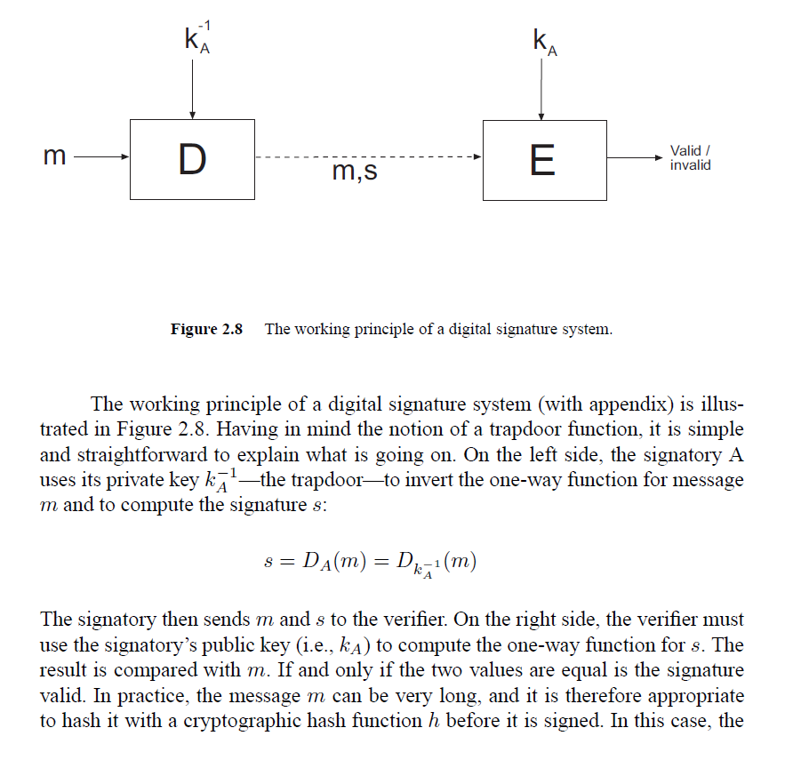
What is the SSL?
The term SSL refers to a layer that is best viewed as an intermediate layer between the transport and the application layer. Its scope of functions is twofold:
- On the one hand, it is to establish a secure (i.e., authentic and confidential)
connection between the communicating peers.
- On the other hand, it is to use this connection to securely transmit higher layer
protocol data from the sender to the recipient. It therefore fragments the data into manageable pieces (called fragments), and processes each fragment individually. More specifically, each fragment is optionally compressed, authenticated with a MAC, encrypted, prepended with a header, and transmitted to the recipient. Each fragment that is treated and prepared this way is called an SSL record.1 On the recipient’s side, the SSL records must be decrypted,verified (with regard to their MACs), decompressed, and reassembled, before the data can be delivered to the respective higher-layer—typically the application layer—protocol.

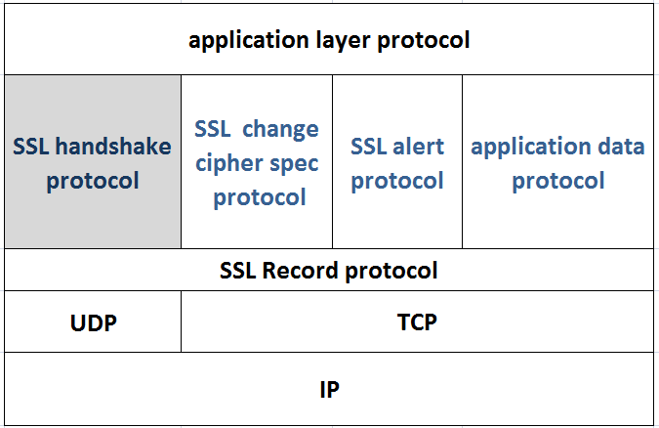
The higher layer is stacked on top of the SSL Record Protocol and comprises
four protocols:
- The SSL Handshake Protocol is the core protocol of SSL. It allows
the communicating peers to authenticate each other and to negotiate a
cipher suite and a compression method used for the communications. As
its name suggests, the cipher suite is used to cryptographically protect
data in terms of authenticity, integrity, and confidentiality, whereas the
compression method is to optionally compress data.
- The SSL Change Cipher Spec Protocol allows the communicating peers
to signal a cipher spec change (i.e., a change in the ciphering strategy
and the way data is cryptographically protected). While the SSL Handshake
Protocol is used to negotiate security parameters, the SSL Change
Cipher Spec Protocol is used to put these parameters in place and make
them effective.
- The SSL Alert Protocol allows the communicating peers to signal indicators
of potential problems and to exchange corresponding alert messages.
- The SSL Application Data Protocol is used for the second function
mentioned above (i.e., the secure transmission of application data). This
protocol is the actual workhorse of SSL: it takes higher-layer—typically
application layer—data and feeds it into the SSL Record Protocol for
cryptographic protection and secure transmission.
So the most important part is to understand the handshake protocol. The SSL Handshake Protocol is layered on top of the SSL Record Protocol. It allows a client and server to authenticate each other and to negotiate items like cipher suites and compression methods. The protocol and its message flows are
Illustrated below.
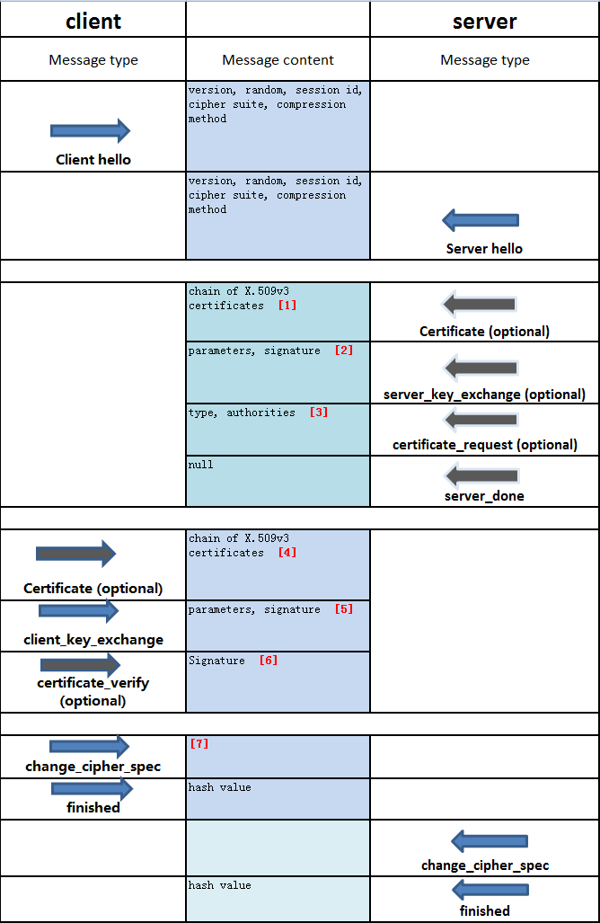
[1] The certificate message is required for any agreed-on key exchange method except anonymous Diffie-Hellman
[2] It is not required in two instances: (1) The server has sent a certificate with fixed Diffie-Hellman parameters, or (2) RSA key exchange is to be used.

The server_key_exchange message is needed for the following:

Anonymous Diffie-Hellman: The message content consists of the two global Diffie-Hellman values (a prime number and a primitive root of that number) plus the server's public Diffie-Hellman key
Ephemeral Diffie-Hellman: The message content includes the three Diffie-Hellman parameters provided for anonymous Diffie-Hellman, plus a signature of those parameters.
RSA key exchange, in which the server is using RSA but has a signature-only RSA key:Accordingly, the client cannot simply send a secret key encrypted with the server's public key. Instead, the server must create a temporary RSA public/private key pair and use the server_key_exchange message to send the public key. The message content includes the two parameters of the temporary RSA public key plus a signature of those parameters.
Fortezza

[3] a nonanonymous server (server not using anonymous Diffie-Hellman) can request a certificate from the client
[4] If the server has requested a certificate, the client begins this phase by sending a certificate message
[5] The content of the message depends on the type of key exchange, as follows:
RSA: The client generates a 48-byte pre-master secret and encrypts with the public key from the server's certificate or temporary RSA key from a server_key_exchange message. Its use to compute a master secret is explained later.
Ephemeral or Anonymous Diffie-Hellman: The client's public Diffie-Hellman parameters are sent.
Fixed Diffie-Hellman: The client's public Diffie-Hellman parameters were sent in a certificate message, so the content of this message is null.
Fortezza: The client's Fortezza parameters are sent.

[6] If the client has provided a certificate with signing capabilities20 in a SERVERHELLODONE message, then it must still prove that it possesses the corresponding private key (the certificate alone cannot authenticate the client). Therefore, the client sends a CERTIFICATEVERIFY message to the server and this message basically comprises a digital signature generated with the client’s private key.

[7] Note that this message is not considered part of the Handshake Protocol but is sent using the Change Cipher Spec Protocol

How to tune the SSL library behavior?
Besides typically doing the handshaking process,we also want those features openSSL library provided.
- Dynamically loading certificate based on the cipher-list supported by client.
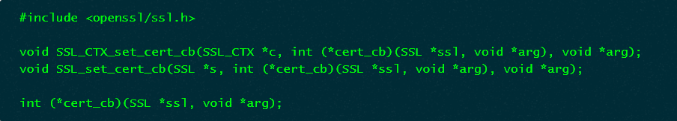
SSL_CTX_set_cert_cb() and SSL_set_cert_cb() sets the cert_cb() callback, arg value is pointer which is passed to the application callback.When cert_cb() is NULL, no callback function is used.
cert_cb() is the application defined callback. It is called before a certificate will be used by a client or server. The callback can then inspect the passed ssl structure and set or clear any appropriate certificates. If the callback is successful it MUST return 1 even if no certificates have been set. A zero is returned on error which will abort the handshake with a fatal internal error alert. A negative return value will suspend the handshake and the handshake function will return immediately.
We register our custom callback function with this logic: parsing the client-sent cipher list to check the cipher suite supported by client,then dynamically setting the context.
- Adding SSL custom extensions
Using extended information the server and the client can exchange extra information needed to accomplish successfully the handshaking process without failure.
After taking all those stuffs into consideration,we design our programming prototype,illustrated below.
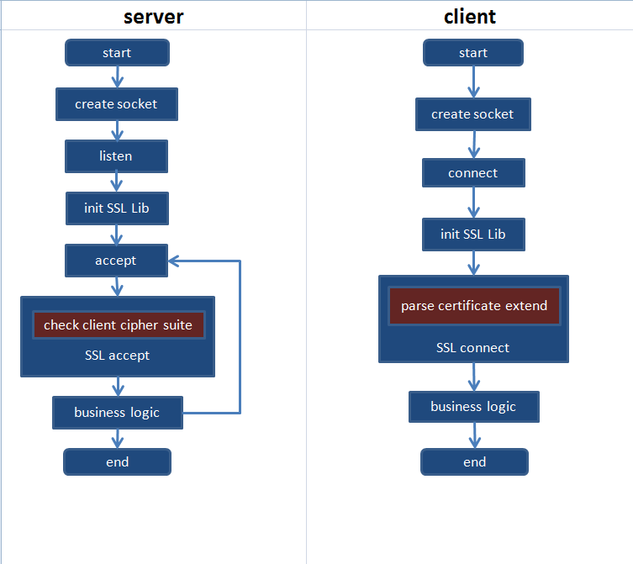
- How to add SSL Custom Extensions?
1 define an array to hold the custom data
#define CUSTOM_EXT_TYPE_3 10000
const char custom_ext_cli_string[] = "client-custom-data";
2 define a callback function to be called by open SSL
static int custom_ext_3_cli_add_cb(SSL *s, unsigned int ext_type,
const unsigned char **out,
size_t *outlen, int *al, void *arg)
{
// the client custom data was added here
if (ext_type != CUSTOM_EXT_TYPE_3)
custom_ext_error = 1;
*out = (const unsigned char *)custom_ext_cli_string;
*outlen = strlen(custom_ext_cli_string);
return 1; /* return 1 means the extension will be included
0 means the extension will not be included */
}
and an parser function to parse the extension sent by server
static int custom_ext_3_srv_parse_cb(SSL *s, unsigned int ext_type,
const unsigned char *in,
size_t inlen, int *al, void *arg)
{
// the code to parse the client-sent data goer here
if (ext_type != CUSTOM_EXT_TYPE_3) {}
return 1;
}
3 register the callback function
SSL_CTX_add_client_custom_ext(c_ctx, CUSTOM_EXT_TYPE_3,custom_ext_3_cli_add_cb,
NULL, NULL,custom_ext_3_cli_parse_cb, NULL);
call this function after the SSL CTX was created.
Do approximately the same thing on the server side.
now, on the server-side make our tailored callback function whose main responsibility is to parse the cipher-suite list to determine which certificate to use,and on the client side retrieve the extension info from certificate sent to us from the server.
how to build openSSL on windows?
for 1.0.2k
If you want to compile in the assembly language routines with Visual
C++, then you will need already mentioned Netwide Assembler binary,
nasmw.exe or nasm.exe, to be available on your %PATH%.
Firstly you should run Configure with platform VC-WIN32:
> perl Configure VC-WIN32 --prefix=c:\some\openssl\dir
Where the prefix argument specifies where OpenSSL will be installed to.
Next you need to build the Makefiles and optionally the assembly
language files:
- If you are using NASM then run:
> ms\do_nasm
- If you don't want to use the assembly language files at all then run:
> perl Configure VC-WIN32 no-asm --prefix=c:/some/openssl/dir
> ms\do_ms
If you get errors about things not having numbers assigned then check the
troubleshooting section: you probably won't be able to compile it as it
stands.
Then from the VC++ environment at a prompt do:
> nmake -f ms\ntdll.mak
If all is well it should compile and you will have some DLLs and
executables in out32dll. If you want to try the tests then do:
> nmake -f ms\ntdll.mak test
To install OpenSSL to the specified location do:
> nmake -f ms\ntdll.mak install
for 0.9.8a
If you want to compile in the assembly language routines with Visual C++ then
you will need an assembler. This is worth doing because it will result in
faster code: for example it will typically result in a 2 times speedup in the
RSA routines. Currently the following assemblers are supported:
* Microsoft MASM (aka "ml")
* Free Netwide Assembler NASM.
MASM is distributed with most versions of VC++. For the versions where it is
not included in VC++, it is also distributed with some Microsoft DDKs, for
example the Windows NT 4.0 DDK and the Windows 98 DDK. If you do not have
either of these DDKs then you can just download the binaries for the Windows
98 DDK and extract and rename the two files XXXXXml.exe and XXXXXml.err, to
ml.exe and ml.err and install somewhere on your PATH. Both DDKs can be
downloaded from the Microsoft developers site www.msdn.com.
NASM is freely available. Version 0.98 was used during testing: other versions
may also work. It is available from many places, see for example:
http://www.kernel.org/pub/software/devel/nasm/binaries/win32/
The NASM binary nasmw.exe needs to be installed anywhere on your PATH.
Firstly you should run Configure:
> perl Configure VC-WIN32
Next you need to build the Makefiles and optionally the assembly language
files:
- If you are using MASM then run:
> ms\do_masm
- If you are using NASM then run:
> ms\do_nasm
- If you don't want to use the assembly language files at all then run:
> ms\do_ms
If you get errors about things not having numbers assigned then check the
troubleshooting section: you probably won't be able to compile it as it
stands.
Then from the VC++ environment at a prompt do:
> nmake -f ms\ntdll.mak
If all is well it should compile and you will have some DLLs and executables
in out32dll. If you want to try the tests then do:
> cd out32dll
> ..\ms\test
If error occurs , edit ntdll.mak script remove /WX switch

more concepts for further study
how key was generated?
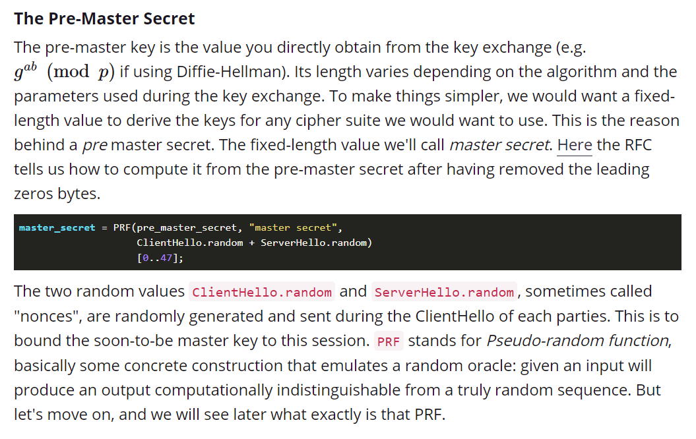
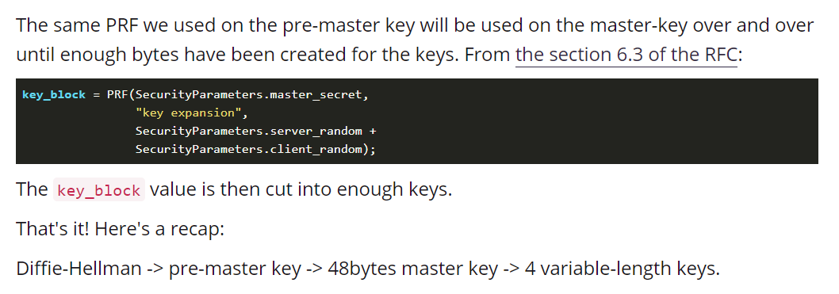
What is mac?
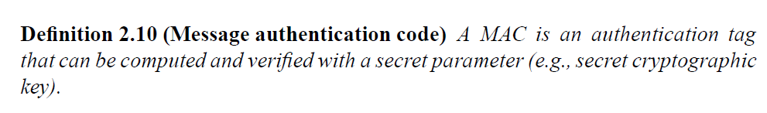
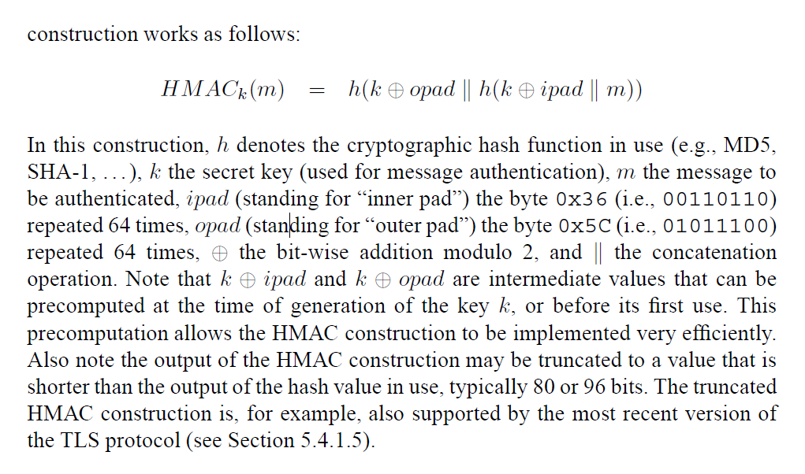
SSL connection and session
Connection: A connection is a transport (in the OSI layering model definition) that provides a
suitable type of service. For SSL, such connections are peer-to-peer relationships. The
connections are transient. Every connection is associated with one session.
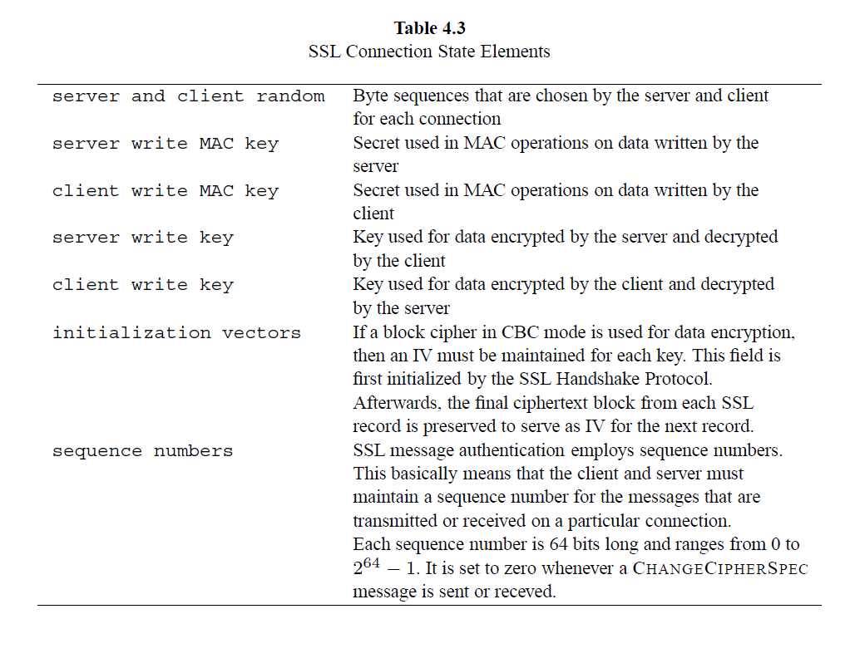
Session: An SSL session is an association between a client and a server. Sessions are created by
the Handshake Protocol. Sessions define a set of cryptographic security parameters, which can
be shared among multiple connections. Sessions are used to avoid the expensive negotiation of
new security parameters for each connection.
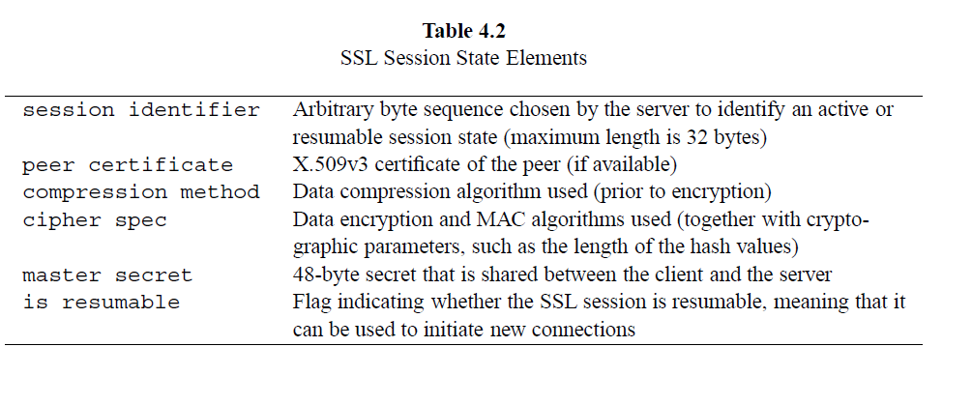

How application data was processed?
We already said that the SSL Record Protocol is used for the encapsulation of higherlayer
protocol data, and that it therefore fragments the data into manageable pieces
(called fragments), and processes each fragment individually. More specifically,
each fragment is optionally compressed and cryptographically protected according
to the compression method and cipher spec of the SSL session state and the
cryptographic parameters of the SSL connection state. The result represents the
fragment of the SSL record sent to the recipient.
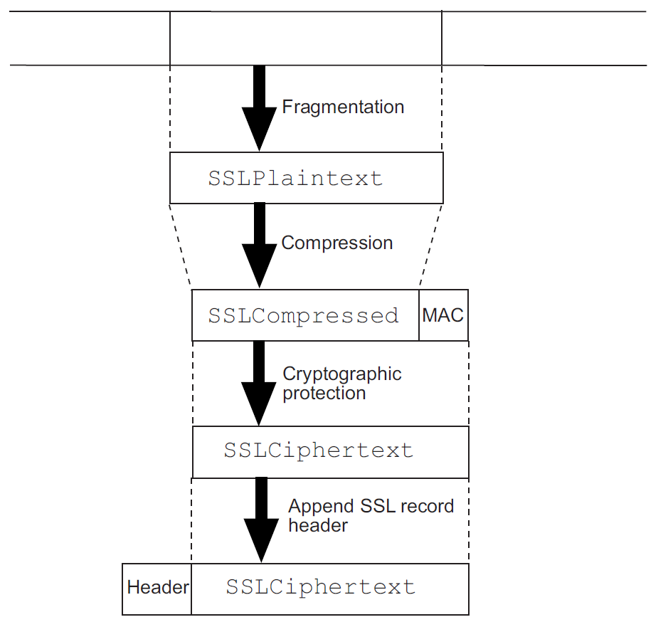

What is key exchange?
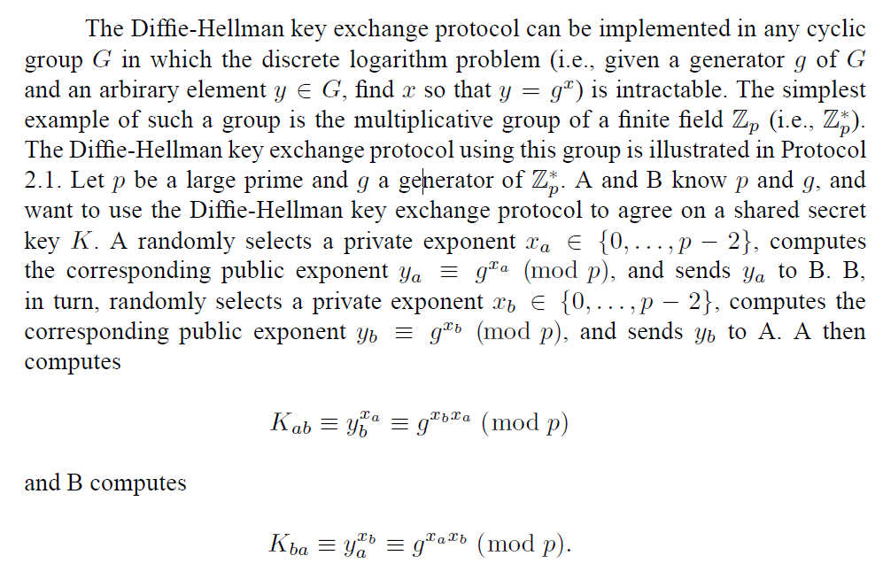
what is FS?
In cryptography, forward secrecy (FS), also known as perfect forward secrecy (PFS), is a property of secure communication protocols in which compromises of long-term keys does not compromise past session keys.

Reference material:
- Cryptography and Network Security Principles and Practices, Fourth Edition chapter 17 section 2
- SSL and TLS: Theory and Practice chapter 4

